**Ideation Phase**

**Empathize & Discover**

|  |  |
| --- | --- |
| Date | 25-08- 2025 |
| Team ID | LTVIP2025TMID60976 |
| Project Name | **Resolve Now : Your Platform for Online Complaints** |
| Maximum Marks | 4 Marks |

**Empathy Map Canvas:**

Understand the needs, frustrations, and behaviors of freelance professionals s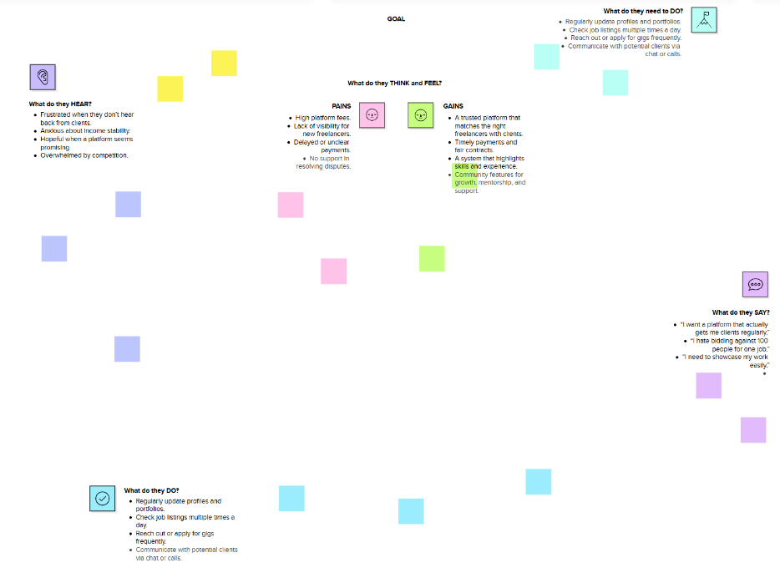

**🧠 Empathy Map Canvas – *ResolveNow* (Complainant Persona)**

**🎯 Persona: A consumer trying to file a complaint about a business or service.**

**👀 SEE**

* **Poor customer service with no way to escalate**
* **No transparent process for follow-up**
* **Complicated or hidden complaint procedures**
* **Platforms that are biased or unresponsive**

**🧠 THINK & FEEL**

* **“Will anyone even read this complaint?”**
* **“I want justice but don’t know how to get it.”**
* **“The process is confusing and emotionally draining.”**
* **“I’m just one voice — what difference will this make?”**

**👂 HEAR**

* **“It’s not worth the hassle.”**
* **“Just move on — they won’t respond.”**
* **“Companies never take complaints seriously.”**
* **“You need a lawyer for this.”**

**🗣️ SAY & DO**

* **Vents frustration on social media**
* **Asks friends for advice on what to do**
* **Tries calling customer support multiple times**
* **Looks for online forms or help centers**

**💥 PAIN**

* **No response or delayed action**
* **Lack of trust in the resolution process**
* **Fear of being ignored or retaliated against**
* **No legal knowledge or support**

**🎯 GAIN**

* **Clear complaint tracking and timelines**
* **Option to stay anonymous**
* **Fair, neutral platform for resolution**
* **Feeling heard and empowered**